**Power BI - Hands-on Assessment**

*By Yuva Sahith Varma Sangaraju*

**Scenario:** Sales Performance Analysis with Power BI

**Data Sources:**

• **Sales Transactions Data**: Contains information about each sale, including product ID, store ID, date, quantity sold, and revenue generated.

• **Product Data:** Includes details about each product, such as product ID, name, category, and price.

• **Store Data:** Provides information about the stores, including store ID, location, and store manager.

**Requirement 1:** Data Loading

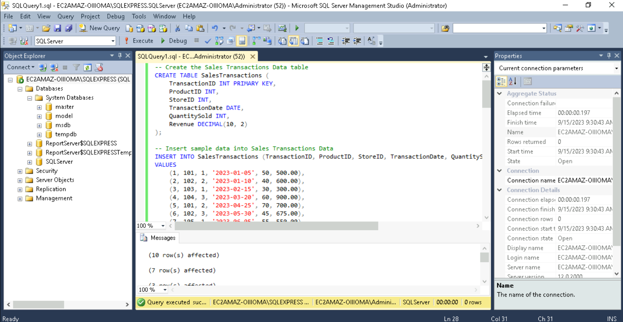

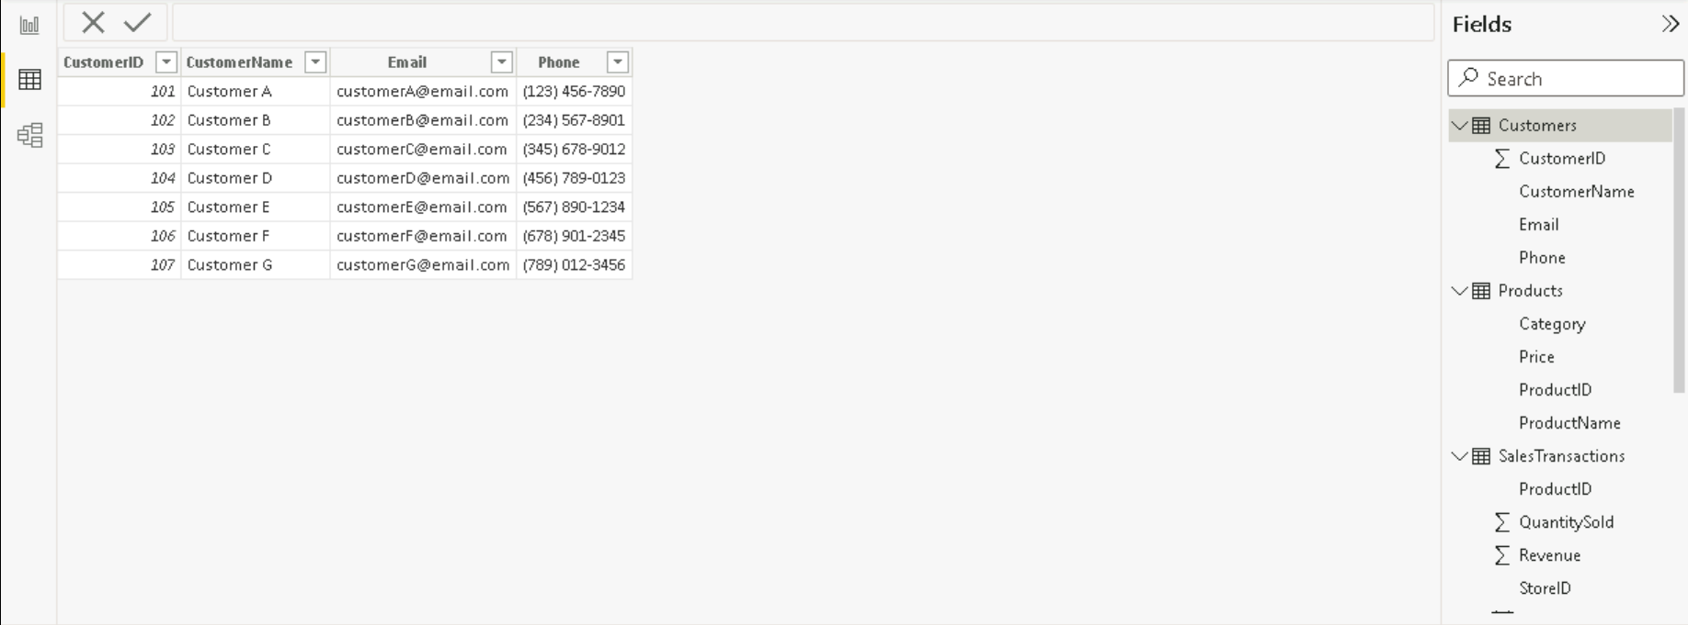

**Requirement 2:** Data Transformation

• Merge Tables:

Product and Sales Transactions:

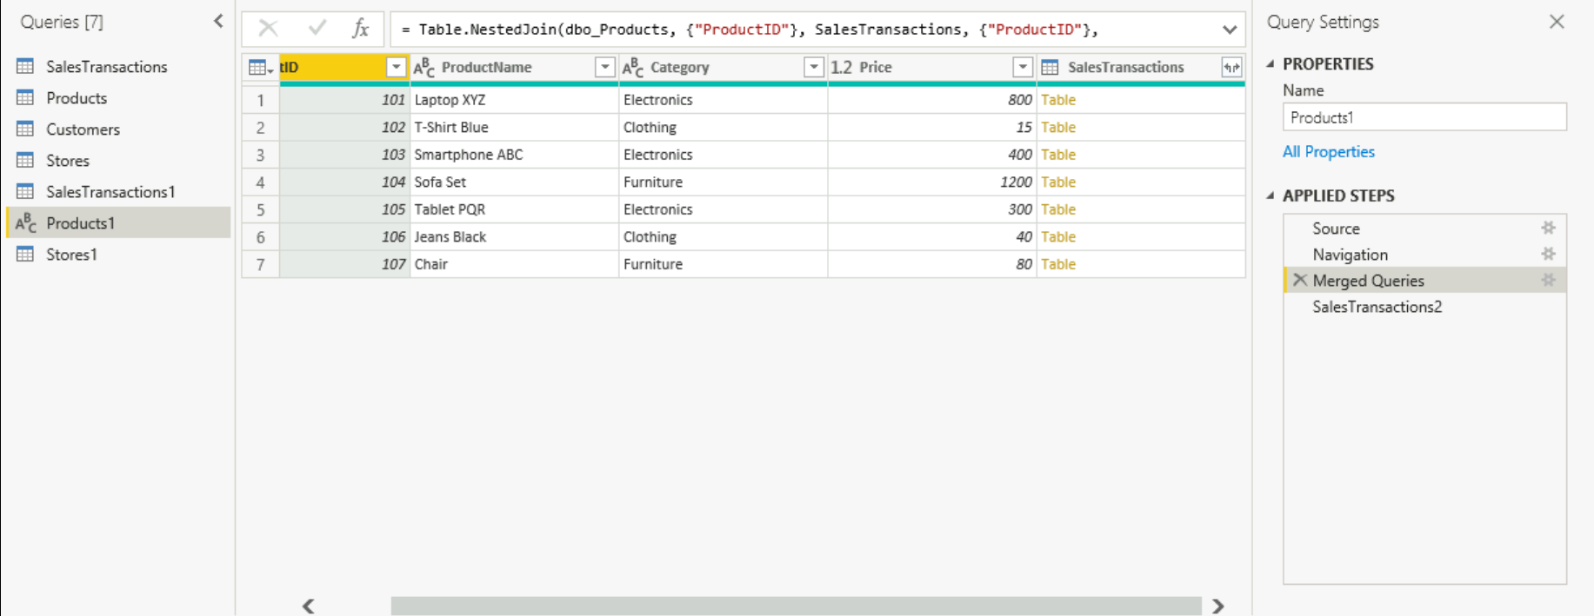

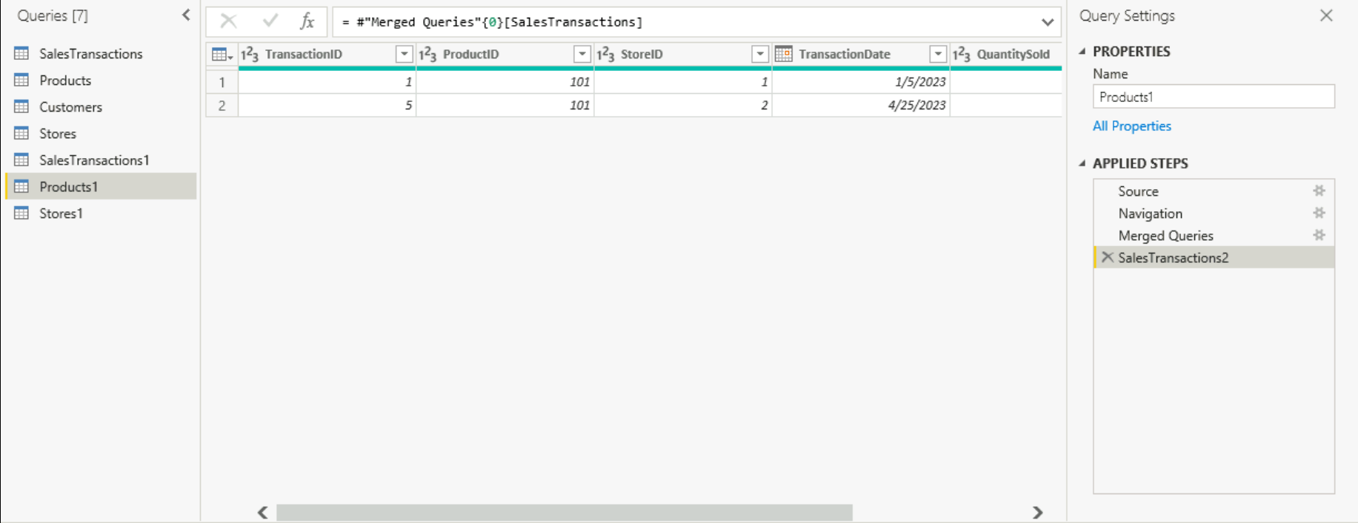

Merging all tables:

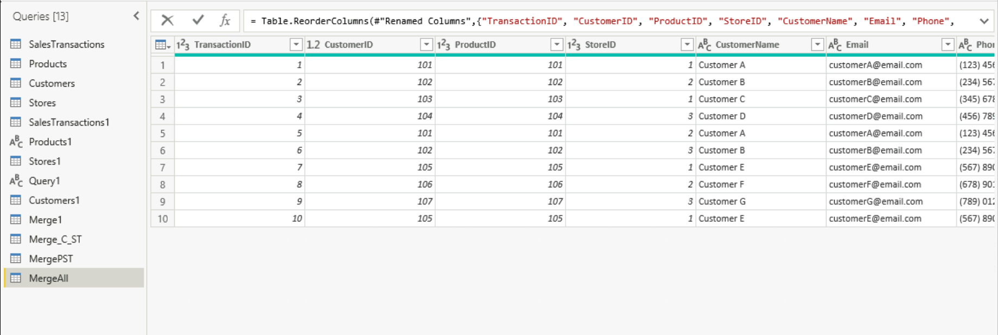

• Clean Data:

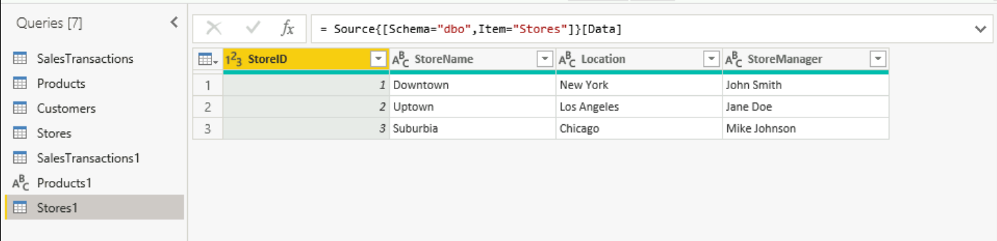

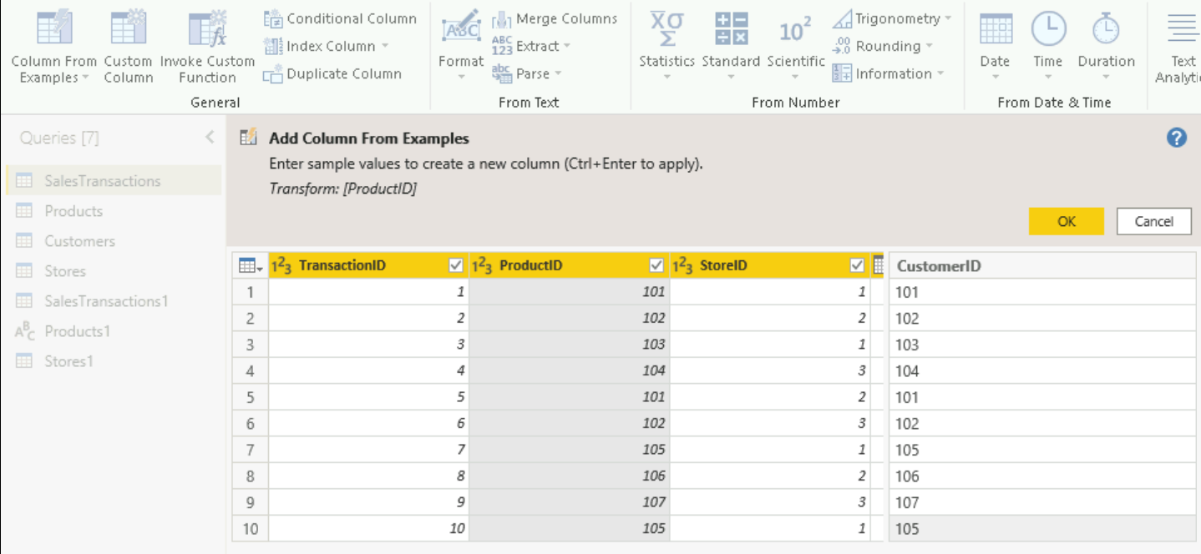

• Create Calculated Columns: Unit Price

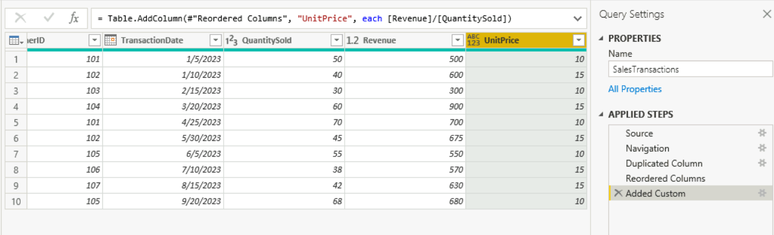

• Filter Data:

Filter expression and graphical representation:

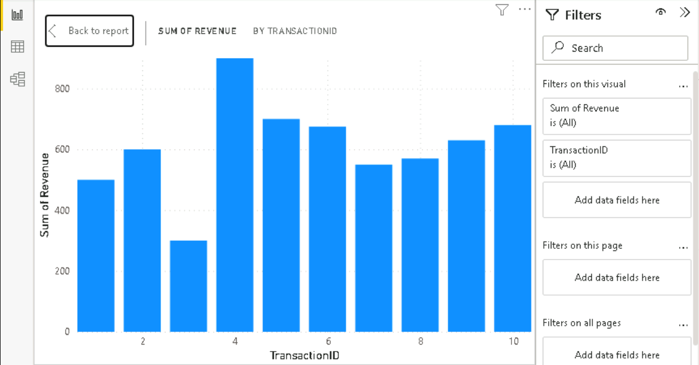

**Requirement 3:** Data Modelling

• Create Relationships:

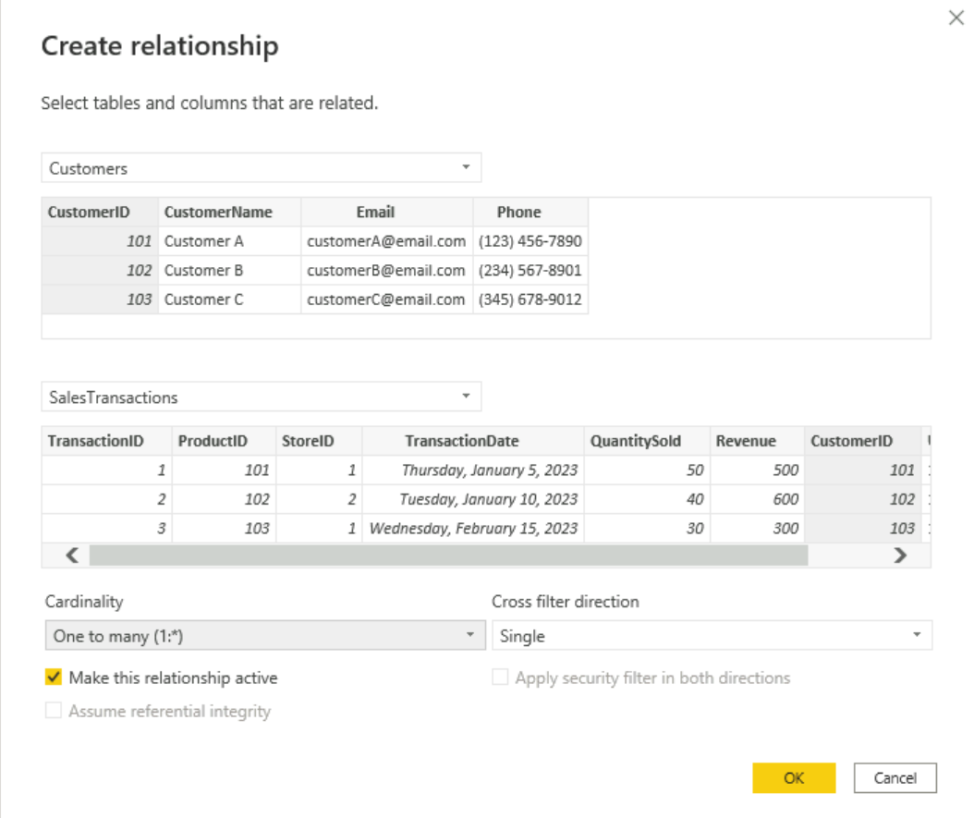

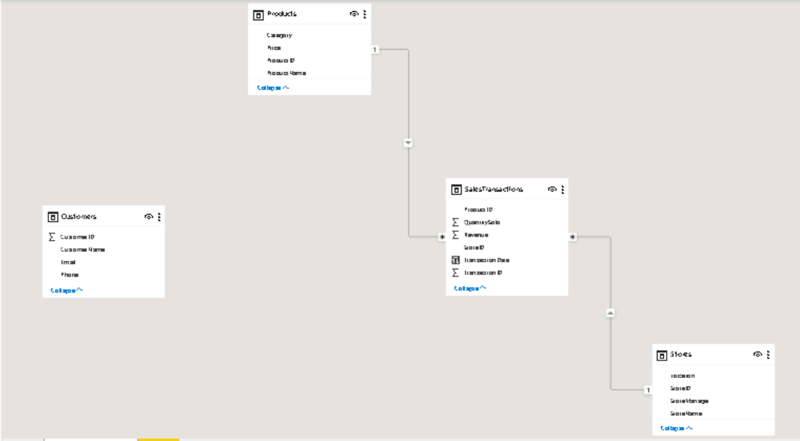

• Create Hierarchies:

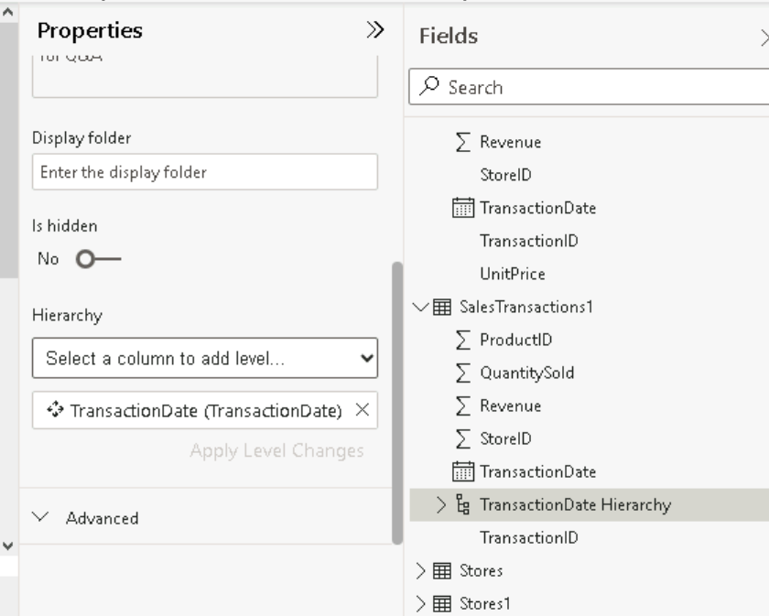

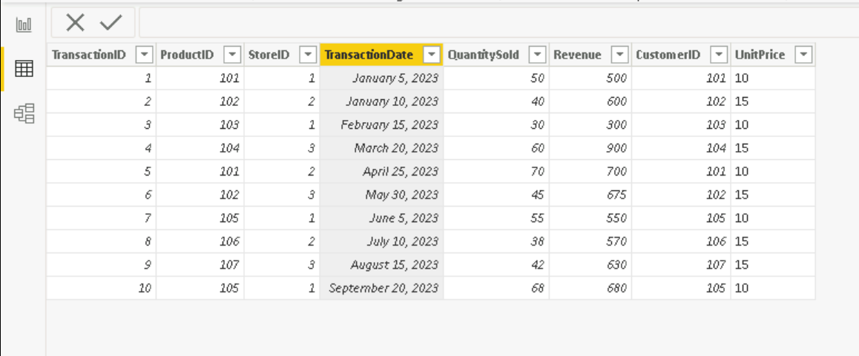

**Requirement 4:** Business Queries and Analysis

1. Who are the top-spending customers based on their total purchase amount?

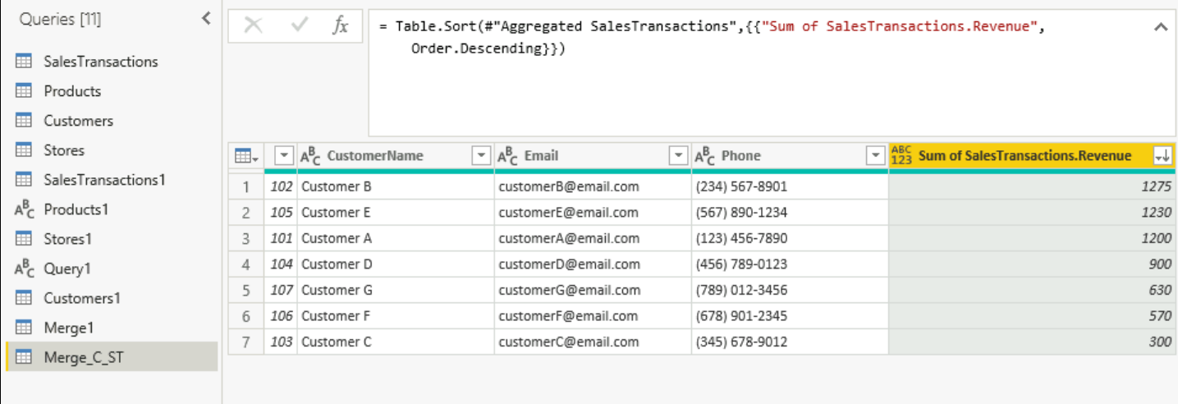

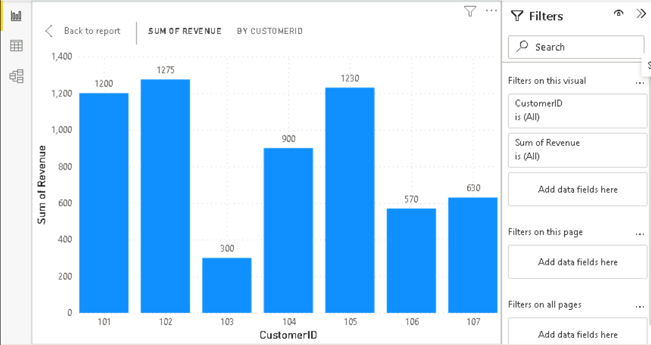

Customer B is the highest spender.

2. How is sales revenue distributed among different store managers?

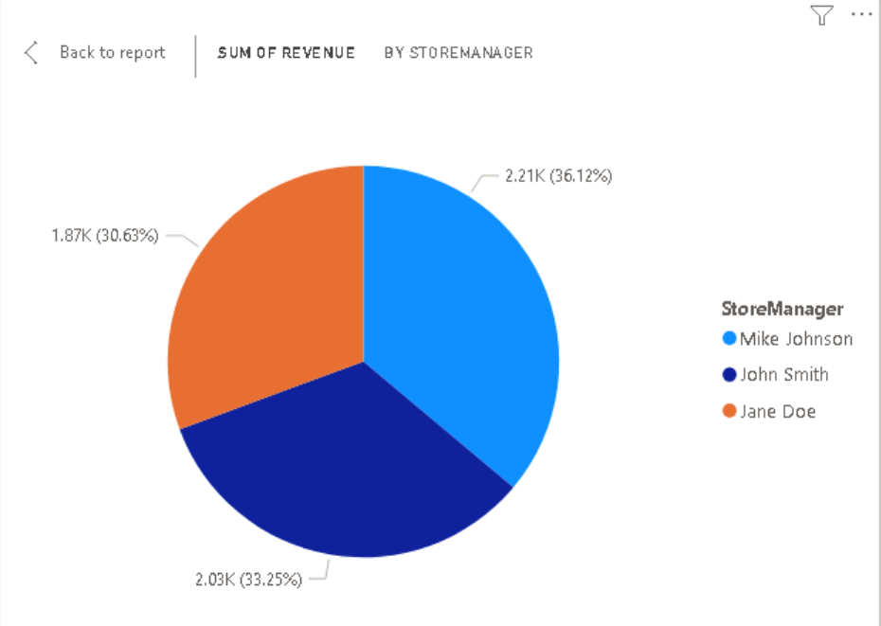

3. What is the average price of products in each category?

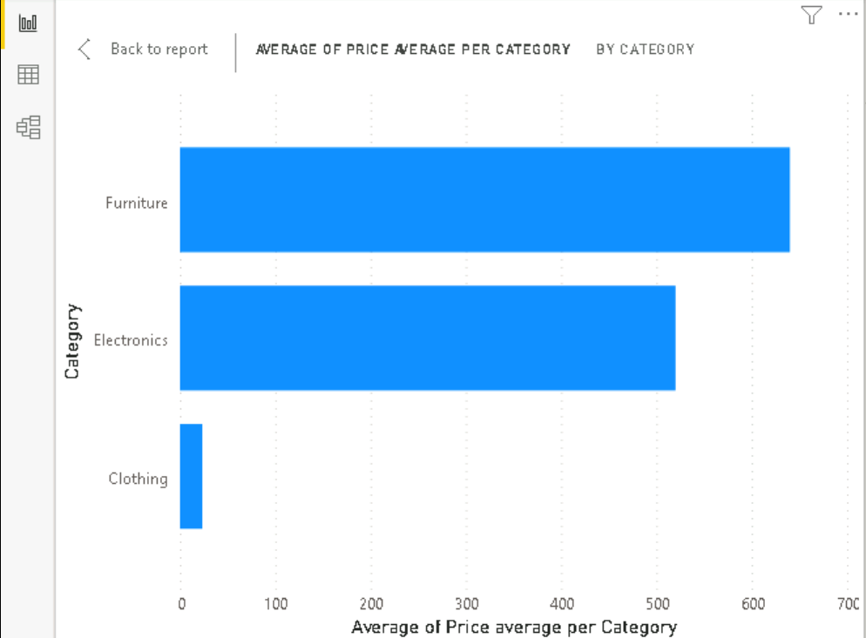

4. Are there specific days of the week when sales are higher?

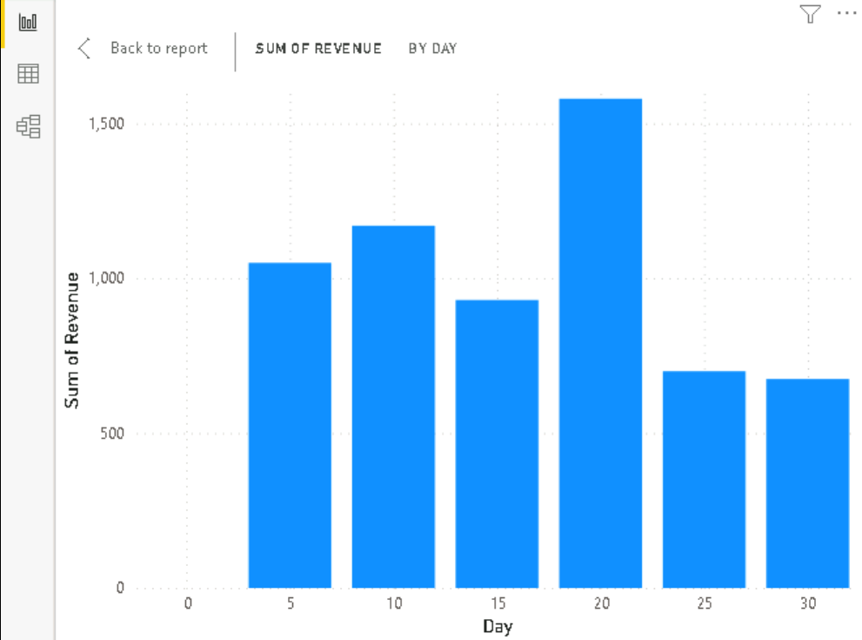

5. How do sales trends vary by product category on a monthly basis?

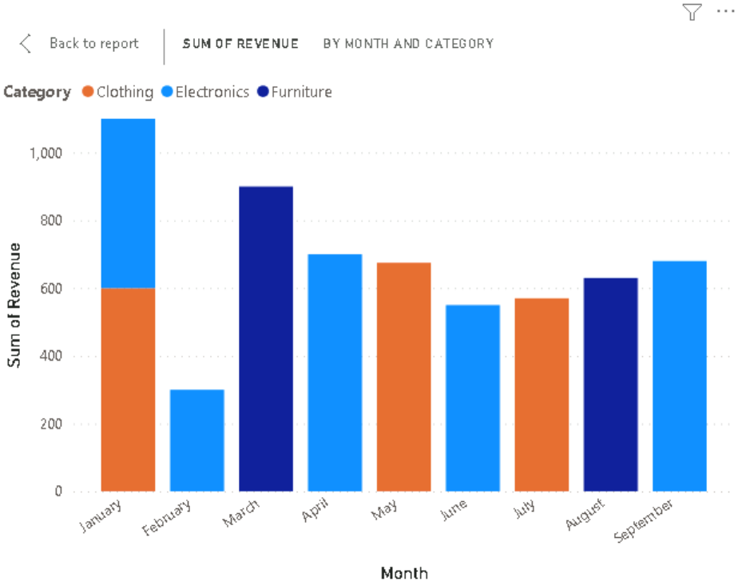

6. What percentage of products account for 80% of total sales revenue?

65% of products

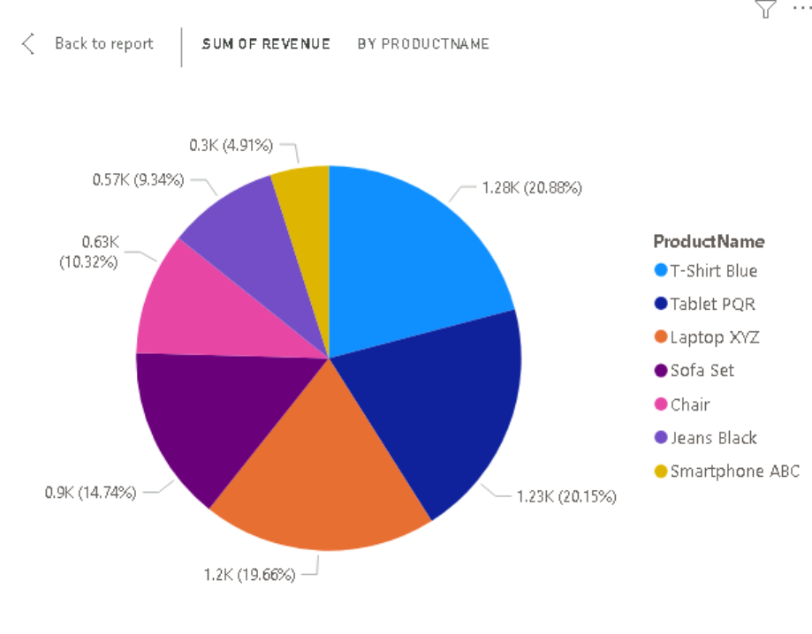

7. Are there any trends in repeat customer purchases?

Yes

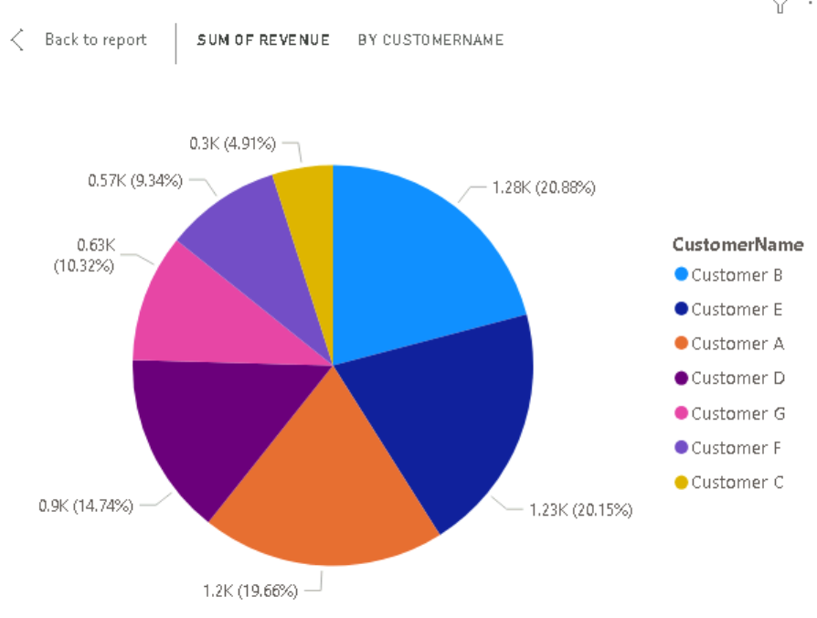

8. Which product categories perform best at each store location?

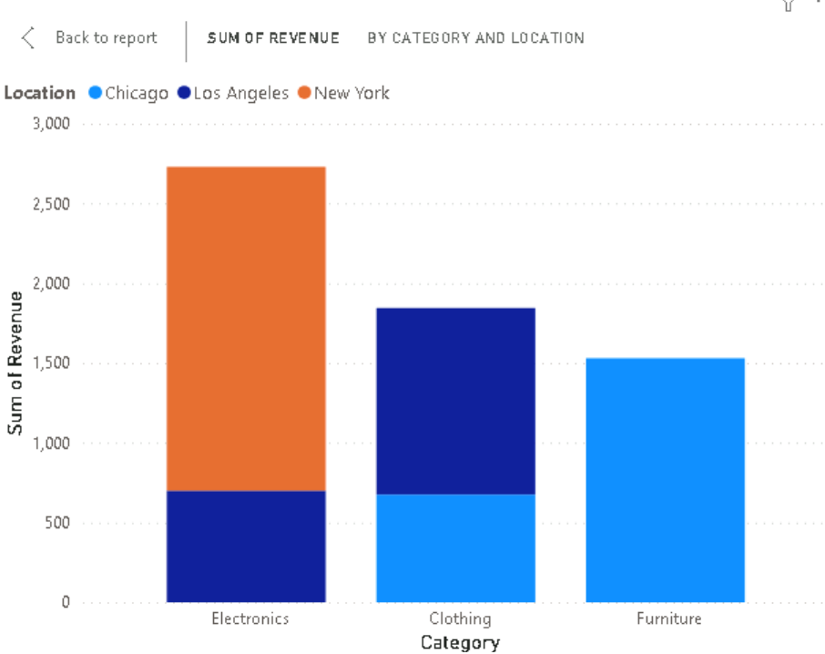

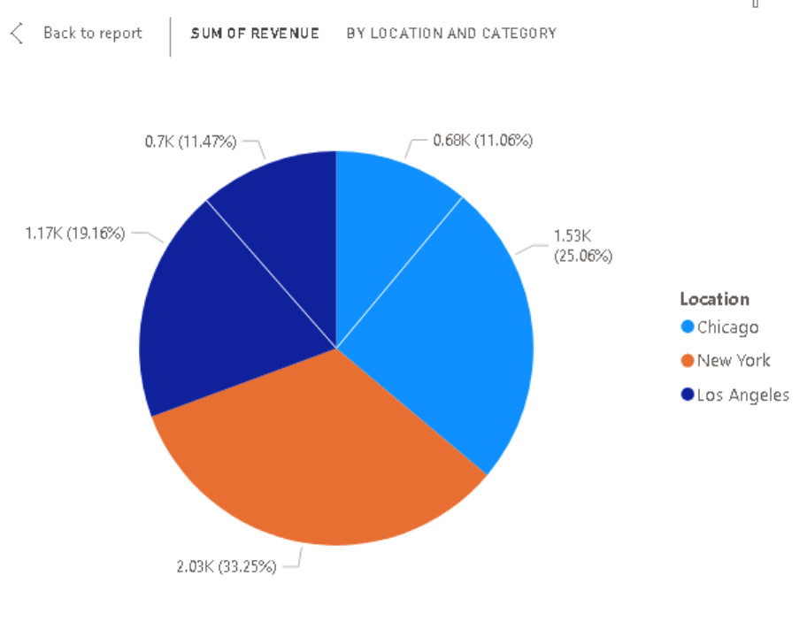

9. Are there any seasonal patterns or trends in sales for specific products or categories?

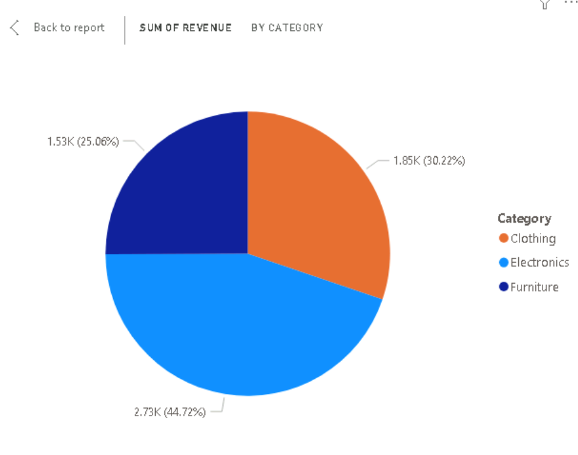

10. Can customers be segmented into high, medium, and low-value segments based on their purchase history?

Yes



**Requirement 5:** Data Insights and Recommendations

• **Analyze Patterns:** Identify patterns and trends in the data, such as seasonality or regional variations and show it or mark it.

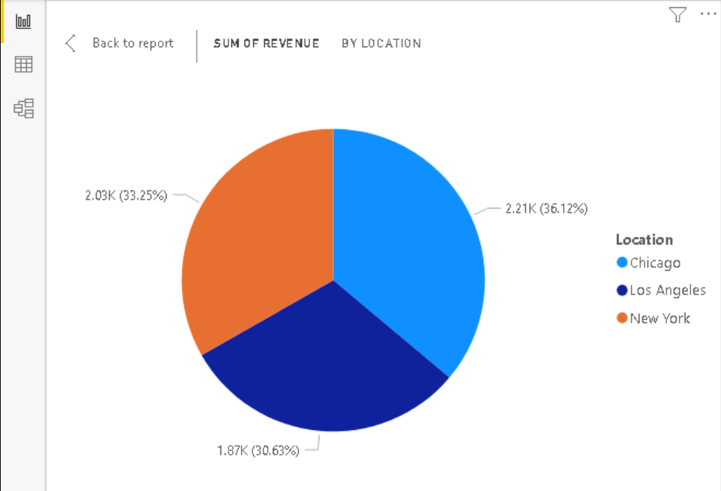

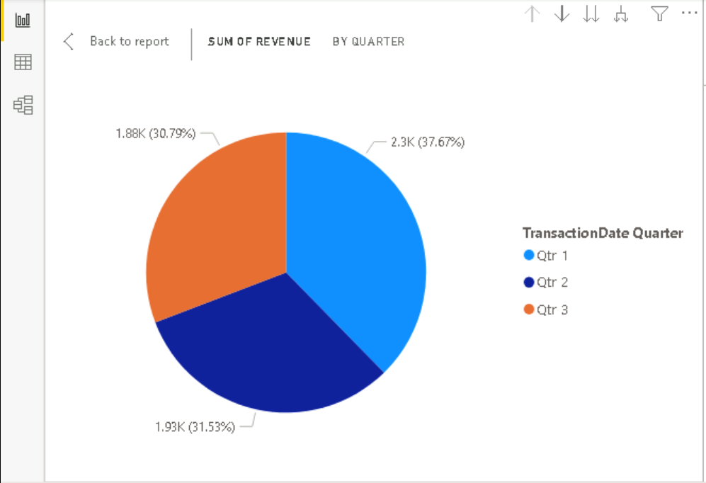

• **Generate Insights:** Provide actionable insights based on your analysis. For example, suggest increasing marketing efforts for the most profitable product category.

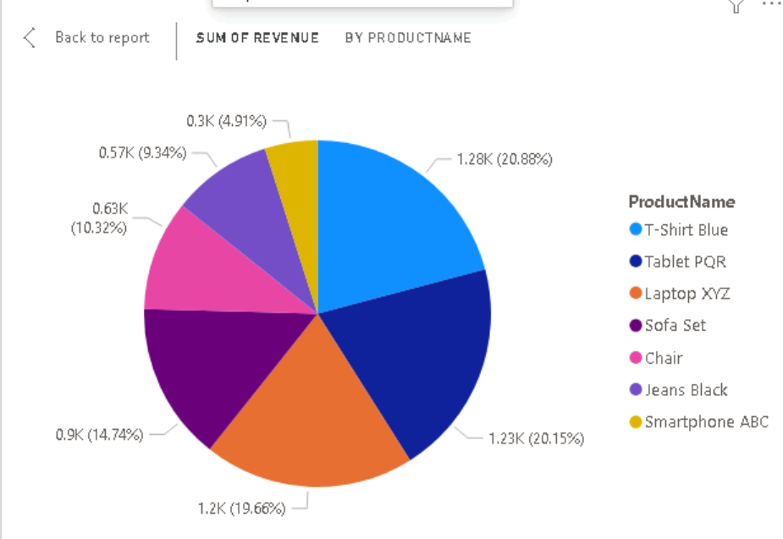

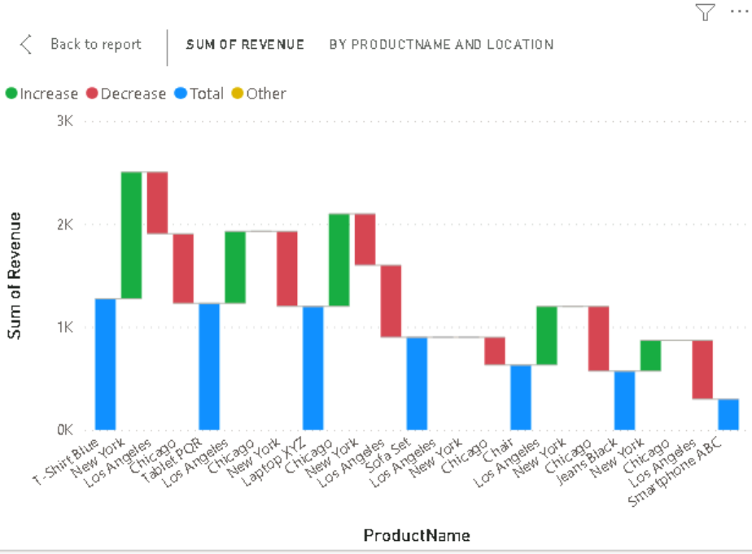

**• Create Visual Stories:** Use storytelling techniques to communicate your findings effectively in the reports and dashboards.

